**25 Arenes and phenols**

**Topic summary**

**•**  **Arenes** are hydrocarbons that contain one or more benzene rings.

**•**  The benzene ring contains a delocalised group of six π electrons. This confers great stability on the system.

**•**  Despite their unsaturation, arenes do not undergo the usual addition reactions associated with alkenes. Their preferred reaction type is **electrophilic substitution**.

**•**  **Aromatic** compounds can be halogenated in either the ring or the side chain, depending on the conditions used.

**•**  Aromatic compounds with alkyl side chains can be oxidised by potassium manganate(VII) to benzenecarboxylic acids.

**•**  Under forcing conditions with hydrogen, the benzene ring can undergo addition rather than substitution.

**•**  **Phenols** are more acidic than alcohols, and can only be esterified by using acyl chlorides.

**•**  The C–O bond in phenols is very strong, and no reactions occur in which it breaks.

**•**  The benzene ring in phenol is much more susceptible to electrophilic attack than is the ring in benzene itself.

**•**  Like alcohols and carboxylic acids, phenol reacts with sodium. Unlike alcohols, it reacts with sodium hydroxide; unlike carboxylic acids, it does *not* react with carbonates.

**Key reactions you should know**

**•**  Electrophilic substitutions:

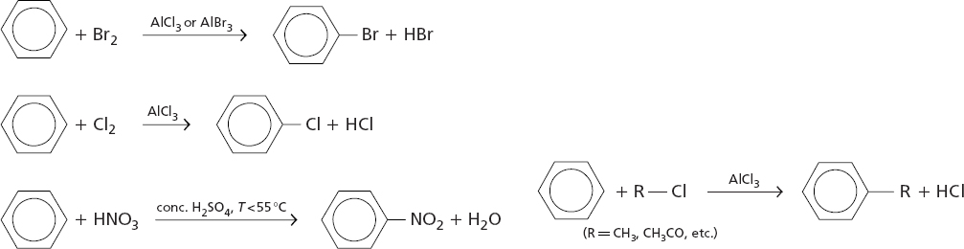

**•**  Side-chain reactions:

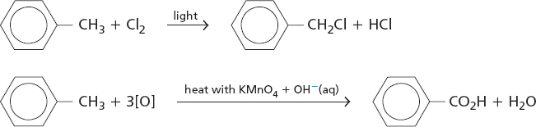

**•**  Reactions of phenols:

